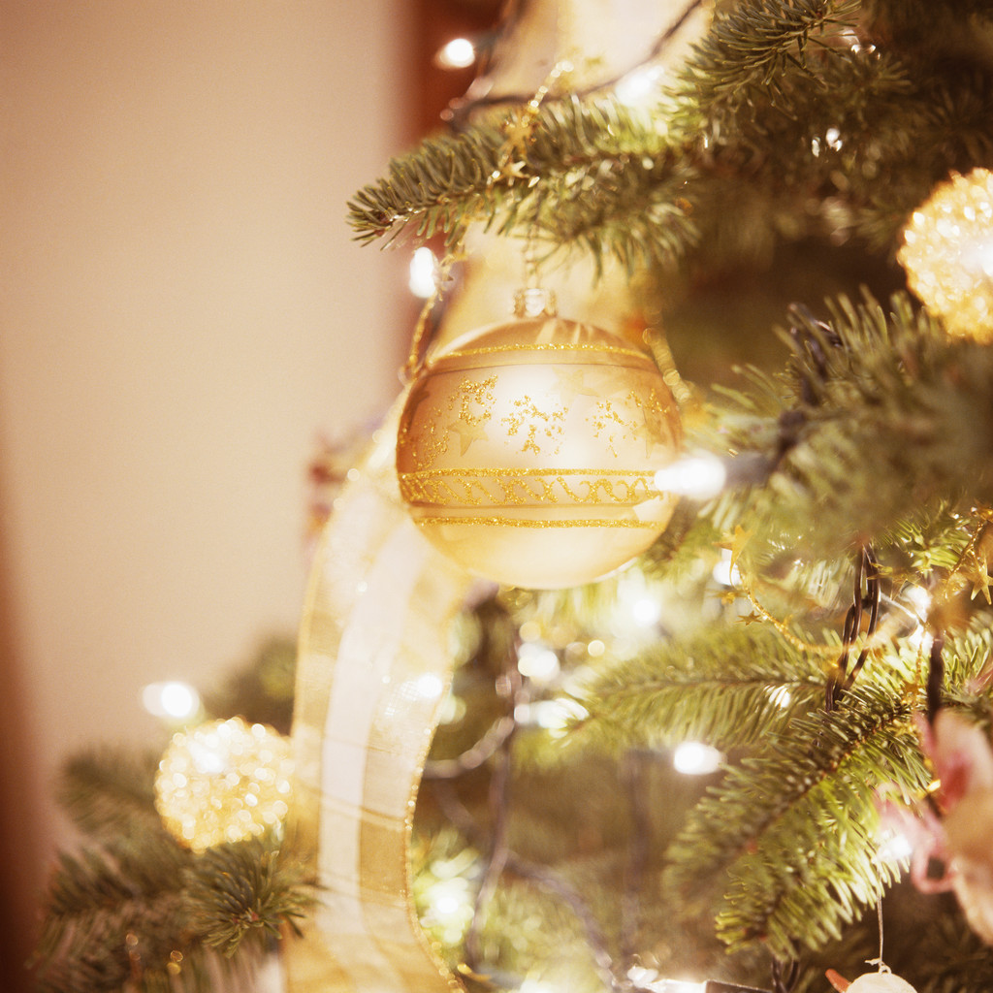

SAVE THE DATE

LADIES SODALITY CHRISTMAS DINNER

SATURDAY, DEC. 9th, 2023 @5pm
St. Paul Knights of Columbus Hall
Raffles, 50/50, Dinner & Drinks. Guest speaker to be announced.
Ages 21+ RSVP by 12/2 to Kristen via call/text (636) 293-1049
For more information, please email the officers: ladiessodality@st-paulchurch.org

