All Things New
Feedback Survey
Guidance Packet

Why are these changes necessary?
- Declining number of Priests in our Archdiocese!
  - 1990 we had 415 Priests for 250 parishes
  - 2022 we have 198 Priests for 178 parishes
  - In the next 10 years, 74 priests will be retiring

We the committee members have spent time discussing the proposed Models & feel it is important to make you aware that there is an opportunity for parishioners to propose a Model “D”.
Make sure your Model “D” takes into account the Decision Criteria (page 2) that the All Things New Strategic Planning Committee is using to make their decisions.
There is NO need for you to immediately respond to the Feedback Survey, you have till December 31st. Please take time to reflect and pray about your thoughtful response. We hope this packet of information will assist you with your response.

Packet Contains:
- Decision Criteria
- St. Paul Parish Workbook highlights
- Current proposed models from the All Things New Strategic Planning Committee
- Model “D” worksheet
  - Use this for creating your proposed Model “D” you would like the Archbishop to consider and why. This will prepare you to answer question 21 on the feedback survey.
- Copy of the Feedback Survey
  - If you can’t submit it on-line you can fill the copy attached out and return it to the parish center for a committee member to input on your behalf.

Please feel free to forward the email you received on October 19th with the Subject -All Things New Parish Listening Session Materials and Online Survey Available to any parishioner or anyone can call the parish center to request the email to be sent to them.

Important Links:
- Parish Listening Session Slides & Videos: https://allthingsnew.archstl.org/Planning-Area-11
- Proposed Model Feedback Survey (anonymous): Archdiocese of St. Louis All Things New Parish Listening Session Fall 2022 Feedback Survey (surveymonkey.com)
- Archdiocese All Things New Website: https://allthingsnew.archstl.org
Decision Criteria

- Our planning area (#11) is proposing 4-5 parishes with a projected 5-6 priests.

- Will the suggested combination of communities be the right ones to foster the opportunity for growth?

- Will it allow for the strengths and opportunities identified through the Disciple Maker Index Survey to be fostered?

- Will it provide necessary Catholic presence and Social Outreach in the area?

- Does it provide for a weekly Mass attendance of 1,000 or more with vibrant liturgy and community?

- Does it provide for the opportunity for Catholic education of our young?

- Does it take into account demographic trends?

- Does it take into account external influences, such as distances, traffic patterns and topography?

- Can they be led and cared for by the projected number of priests?

- Do the models have the resources to support robust communities, evangelization, and ministry long term?

St. Paul Parish Workbook Highlights

- 2nd fastest growing parish in the diocese
  - (Population grew 53% between 2010 & 2020 – nearly twice that in 20 years)
- Baptisms growing and exceeding funerals
- Growing school enrollment
- Pre-Covid Mass attendance growing and higher than the archdiocese’s average
- Steady growth year over year in revenue & reserves
- 4th fastest growing Planning Area in the diocese (grew 53%)
- 35% of the resident population is Catholic which is well above the archdiocesan average of 18% (basically double)
- “This is a very Catholic area”
- Registered Households have grown from 650 to 850 in 10 years
  - (Grown rapidly as the area has grown rapidly)
- Over 50% of 8th graders go to Catholic High School
- St. Paul School has become a regional school drawing significant number of students even from parish areas with strong schools
- 51% of Catholic school students in St Paul territory attend St. Paul School
- The school has grown in the past 6 years
- The parish school is enrolling an increasing number of non-parishioner students
- PSR enrollment has been stable
- Offertory contributions have grown as the parish has grown
- Parish school subsidy has recently become in line with recommended levels (20% to 30%)
- Revenue has generally exceeded expenses, allowing reserves to grow
- Parish & School facilities are well maintained
- A very young demographic area with high baptisms
- Numerous opportunities for Evangelization with our young demographic area

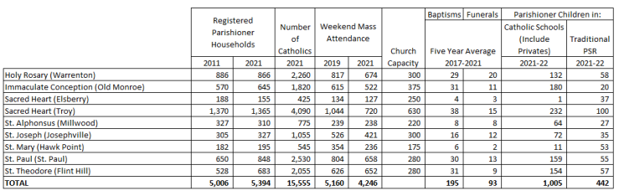
Model Option A

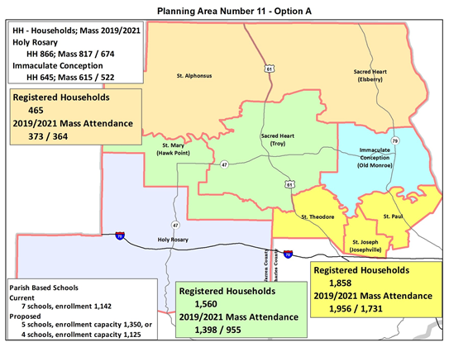

Model Option B-1

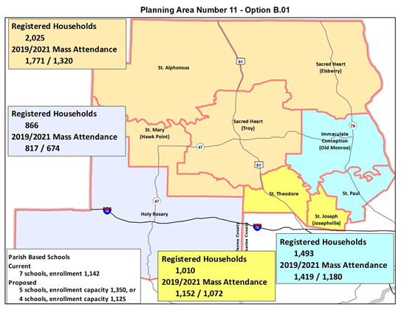

Model Option B-2

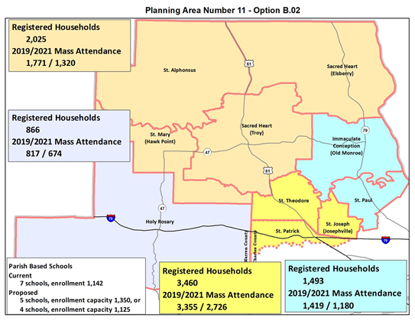

Model Option C

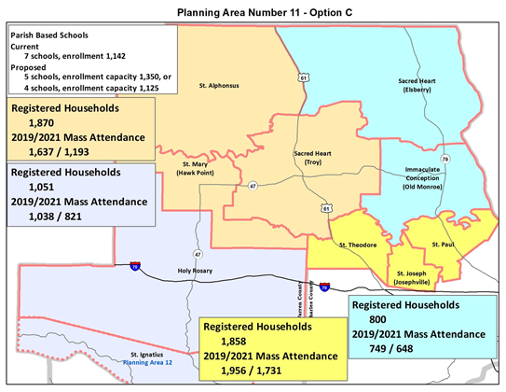

Model Option “D” - Worksheet

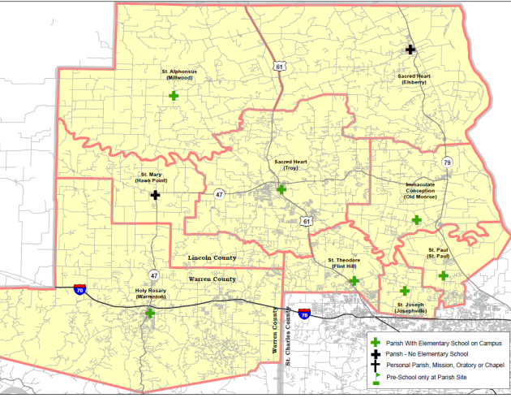
Create your Model “D” based on the Decision Criteria on Page 2 and use this to respond to question 21 on the feedback survey.

________________________________________________________________________

________________________________________________________________________

________________________________________________________________________

